CIND719 - BIG DATA ANALYTICS TOOLS

Mohammed Amir

Assignment # 1 – Programming HIVE

October 23, 2016

1. How many records are there in both tables?

* SELECT COUNT(*) FROM UITEM

1682 records in uitem table

* SELECT COUNT(*) FROM UDATA

100000 records in udata table

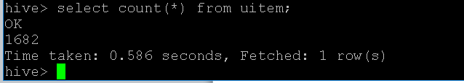

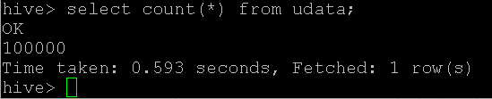

2. Find the name of all movies released in 1990.

SELECT movie_title

From uitem

Where year(release_date) = 1990;

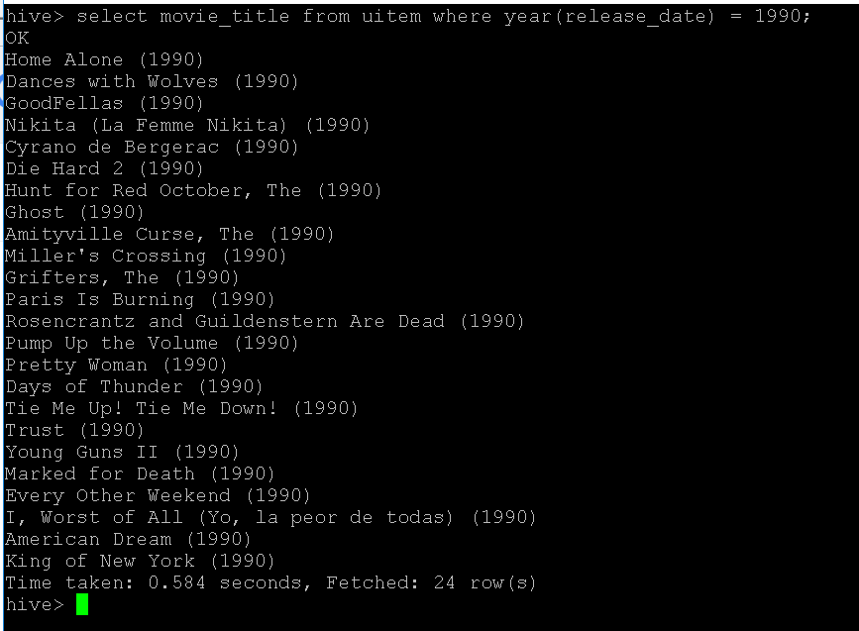

3. List the movieid of the 10 films that received the most ratings (not necessarily highest rating) in the table you created from u.data.

SELECT item_id, count(rating) as favorit

FROM udata

GROUP BY item_id

ORDER BY favorit desc limit 10;

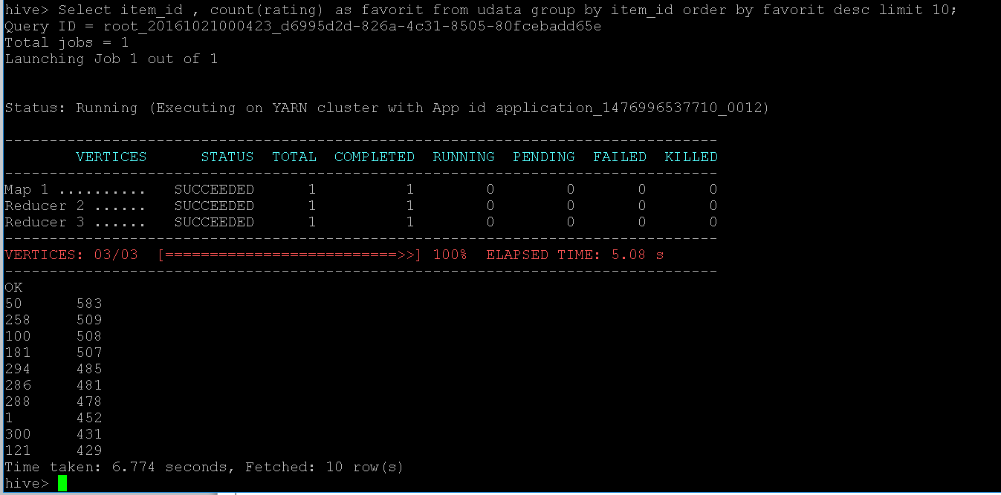

4. Use a join to list the titles of the movies you found in step 3.

select count(a.rating) as favorit,

b.movie_title from udata as a,

uitem as b

where a.item_id = b.movie_id

group by b.movie_title

order by favorit desc

limit 10;

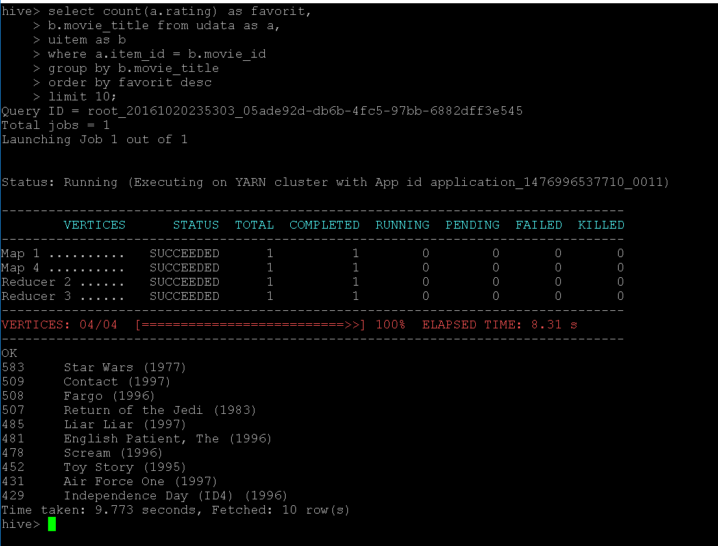

5. Find the highest rated sci_fi movie. Explain how you define "highest rating".

* The highest rated sci_fi movie is one that has the most 5 star rating. The movie that has the highest count of 5 start rating in sci_fi category is Star Wars with 325 counts.

select b.movie_title as Movie_Title, count(a.rating) as Total_5_Star_Rating

from udata as a, uitem as b

where a.item_id = b. movie_id and b.sci_fi = 1 and a.rating = 5

group by b.movie_title

order by Total_5_Star_Rating desc

Limit 1;

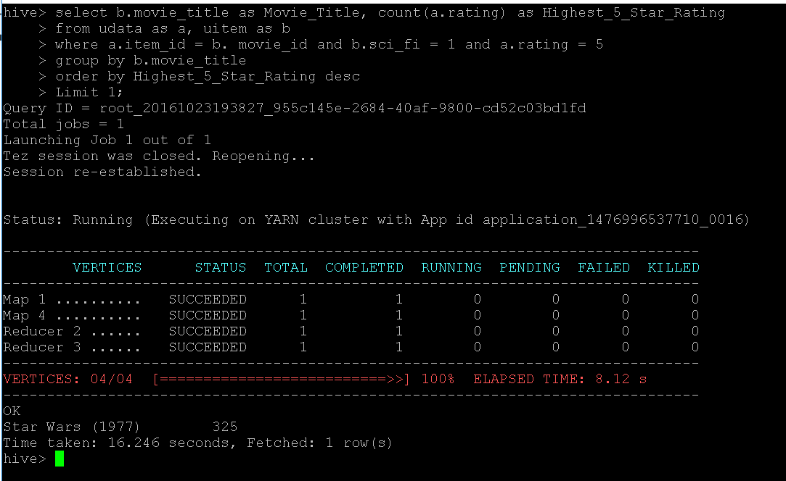

6. BONUS: Are there any movies with no ratings? (Hint: outer join and IS NULL)

* All movies have ratings.

select b.movie_title as Movie_Title, a.rating

from udata as a

LEFT OUTER JOIN uitem as b

ON a.item_id = b. movie_id

where a.rating IS NULL;

